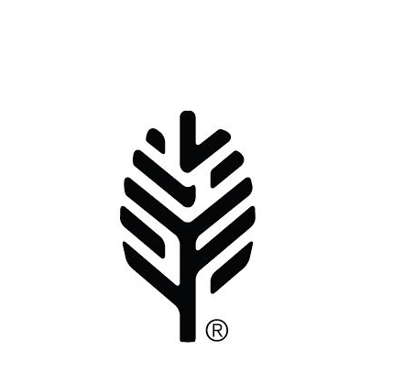
Forest Springs®

2017 Program Activity Waiver

ALL PARTICIPANTS MUST READ THIS RELEASE OF LIABILITY FORM PRIOR TO SIGNING AND
PARTICIPATING IN PROGRAM ACTIVITIES

Agreement to personally assume all risk and release of all claims for liability and waiver of right to sue based upon my understanding of these activities and there inherent risks.

I (full name) of (city and state)
having the date of birth of (month) , (day) , (year) desire Forest Springs, Inc., a Wisconsin not for profit corporation, to permit me to participate in the following described activity. (check the box or boxes that describe your activity)

HIGH ROPES COURSE LOW ROPES COURSE PAINTBALL

In order to participate in the above mentioned activities, I, the undersigned, agree and acknowledge that:
There is risk of injury, including a potential for permanent disability or death resulting from any participation in the above mentioned activities and or from the equipment involved in participation in such activities.
I freely assume all such risks, both known and unknown and assume full responsibility for my participation.
I will read and understand the rules of play, including all safety related rules, and agree to fully comply with the rules and safety regulations during my participation.
I, for myself and on behalf of my heirs, assigns, personal representatives and next of kin hereby release and hold harmless Forest Springs, their officers, officials, agents and or employees, from any and all liability for injury, disability, death, loss or damage to personal property.
I acknowledge, understand and agree that I have read this release of liability and assume all risk associated with participating in the above mentioned activities and that I sign this release of liability voluntarily and without inducement.

All program activities, and handling and use of program equipment
must be supervised by Forest Springs Staff.

Participant’s Name (Please Print): ____________________________________Date of Birth:_____________________

Street Address: __________________________________________________________________________________

City, State: ____________________________________________________Zip Code: _________________________

Phone: __________________________ Email: ________________________________________________________

Participant Signature:_____________________________________________________ Date: ___________________

MINOR AGED PARTICIPANTS
All players under the age of 18 at the time of participation must have a parent or guardian sign below.
I certify that I am the parent or guardian of ________________________ with legal responsibility for the above signed participant and agree to his/her release and agree to indemnify the above named companies and individuals from all liabilities resulting from his/her participation in the above mentioned program activities for myself, my heirs, assigns and next of kin.

Parent or Guardian Signature:______________________________________________ Date: ___________________

This form must be completed upon your arrival to Forest Springs.
Forest Springs reserves the right to deny any person or group participation on the Paintball Course at any time based on equipment, weather, and behavior.

